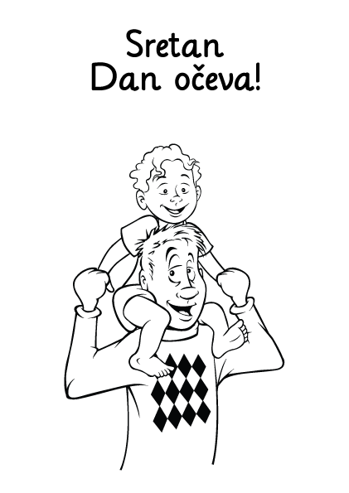

U petak, 18.03., učenici Produženog boravka su kroz radionice obilježili Dan očeva. Izrađivali su čestitke i prigodne poruke za svoje očeve.



